Nalongsone Danddank Student ID : 14958950 StarID: jf3893pd

Email: [nalongsone.danddank@my.metrostate.edu](mailto:nalongsone.danddank@my.metrostate.edu)\

**ICS 432 - 01 — Distributed and Cloud Computing Fall 2021**

**Lab #11 :** NoSQL Databases: AWS DynamoDB and GCP Firestore

Exercise 1: Reading JSON Documents using Python

**Lab report screen-shot #1:**

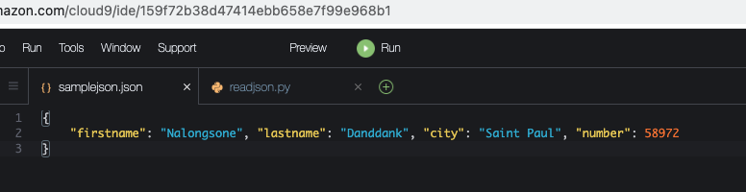

**Lab report screen-shot #2:**

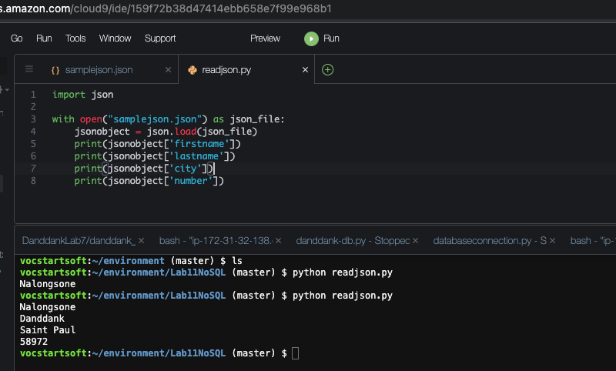

**Exercise 2: Working with AWS DynamoDB**

**Part 1: Working with DynamoDB using AWS Console**

**Lab report screen-shot #3:**

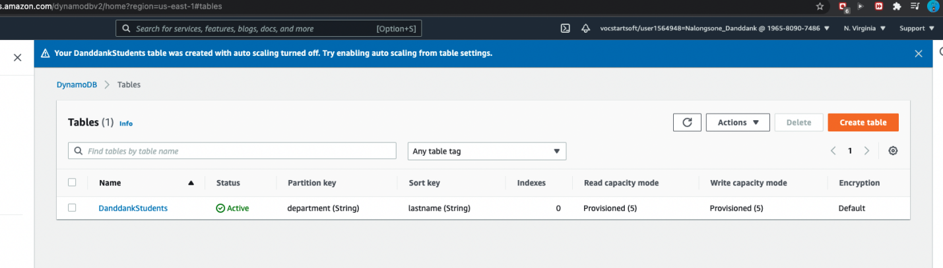

**Lab report screen-shot #4:**

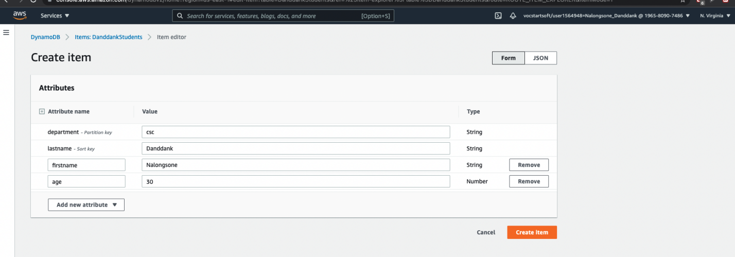

**Lab report screen-shot #5:**

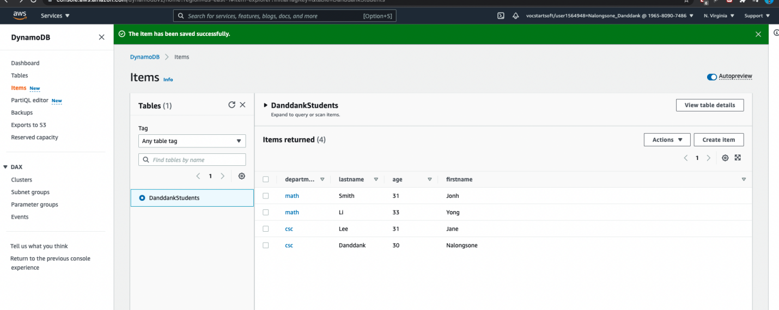

**Lab report screen-shot #6:**

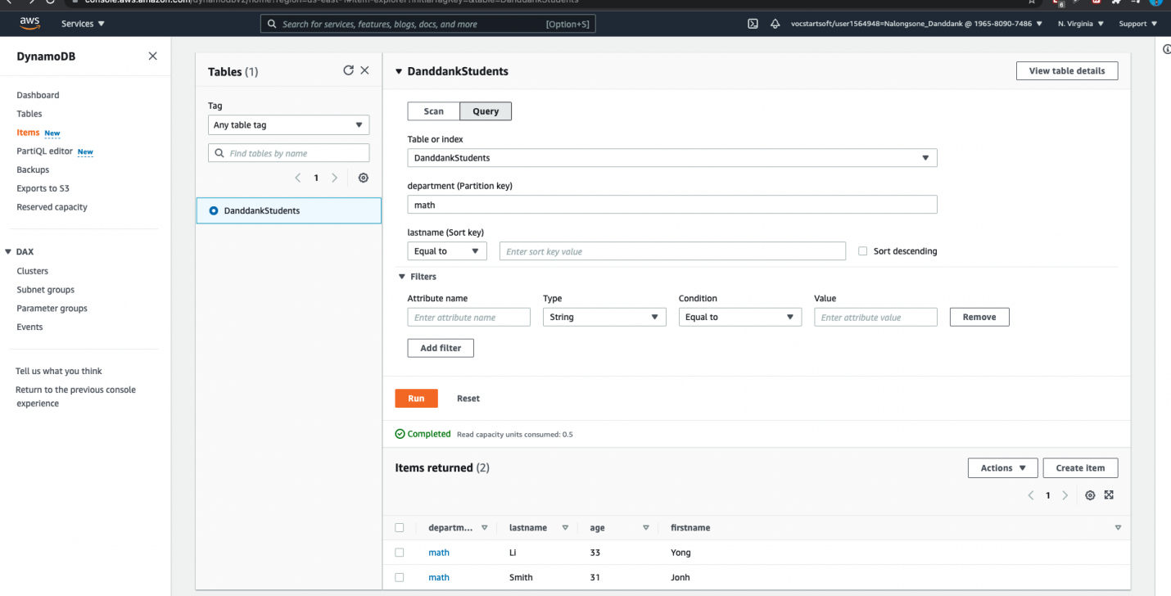

**Part 2: Working with DynamoDB using Python SDK**

**Lab report screen-shot #7:**

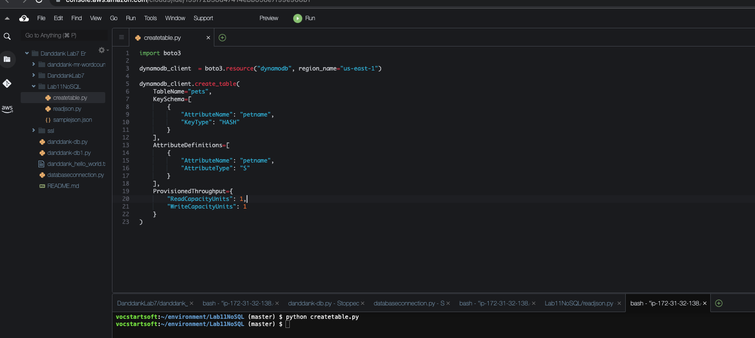

**Lab report screen-shot #8:**

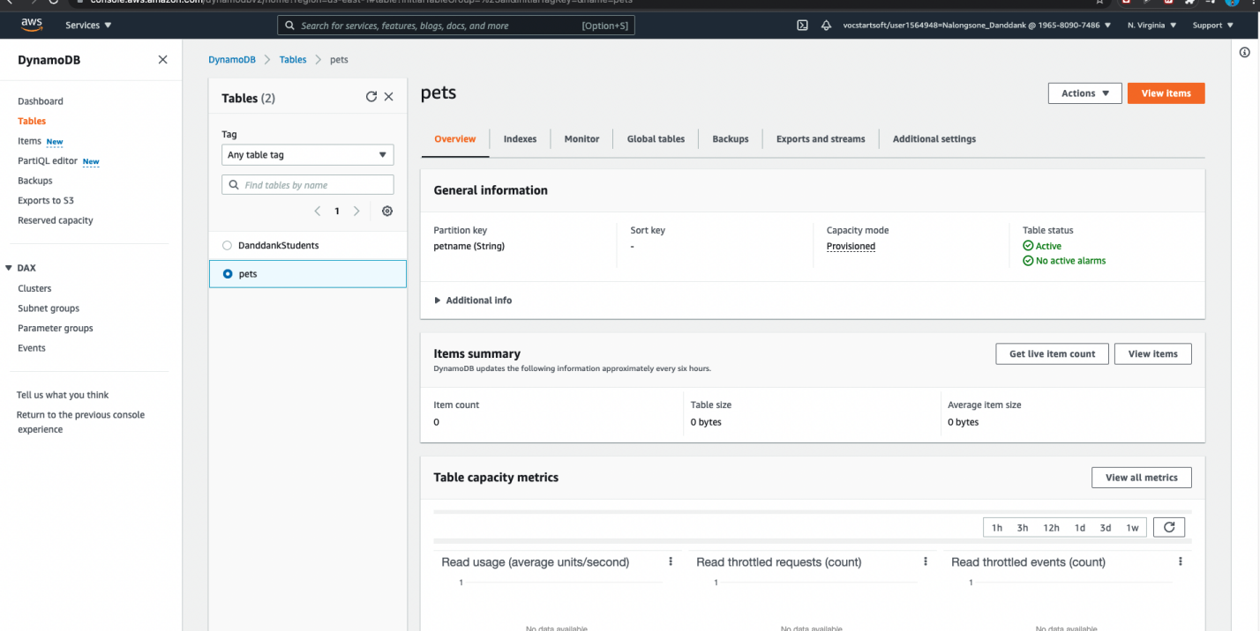

**Lab report screen-shot #9:**

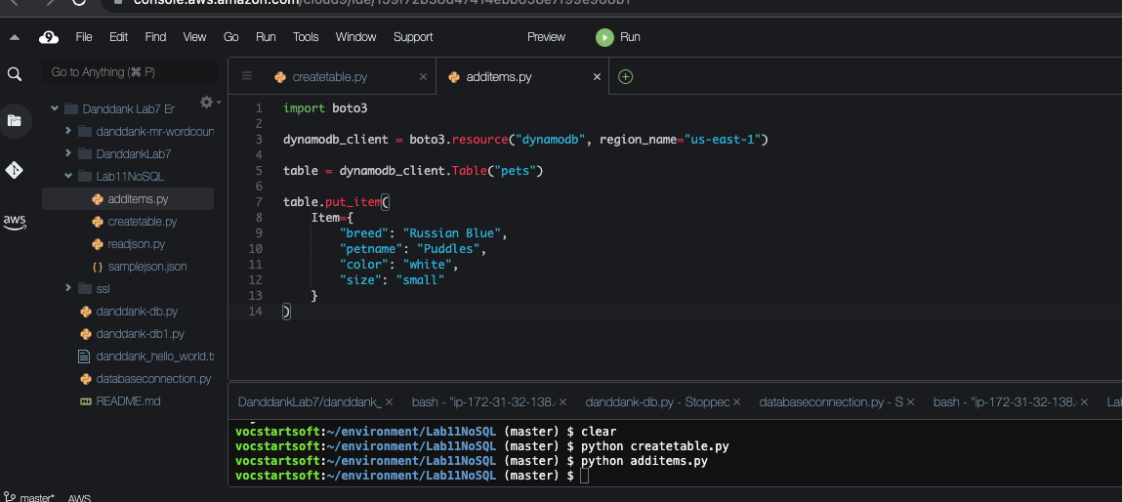

**Lab report screen-shot #10:**

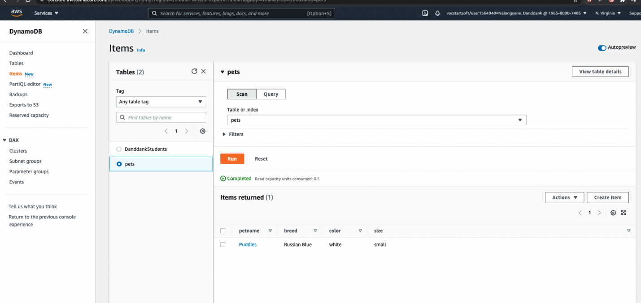

**Lab report screen-shot #11:**

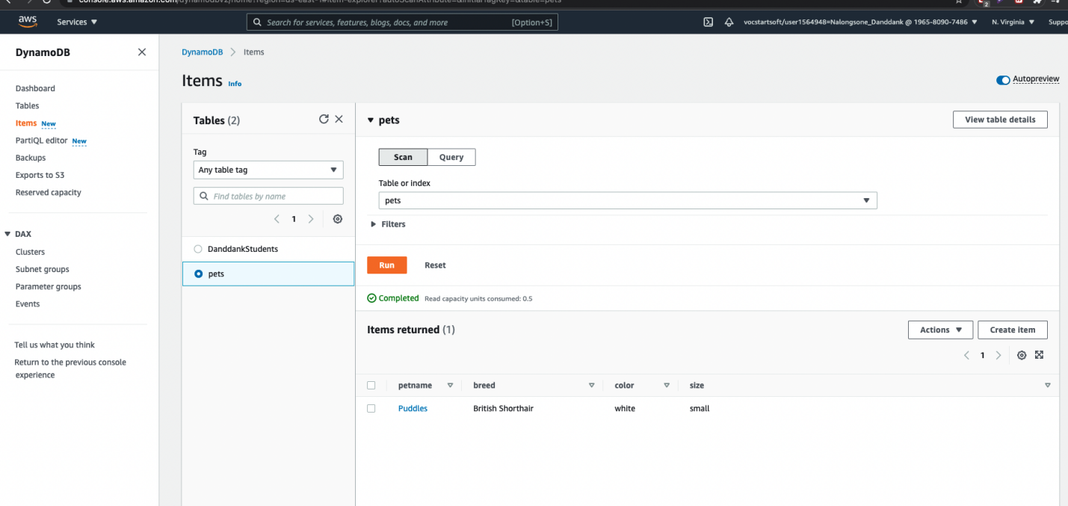

**Lab report screen-shot #12:**

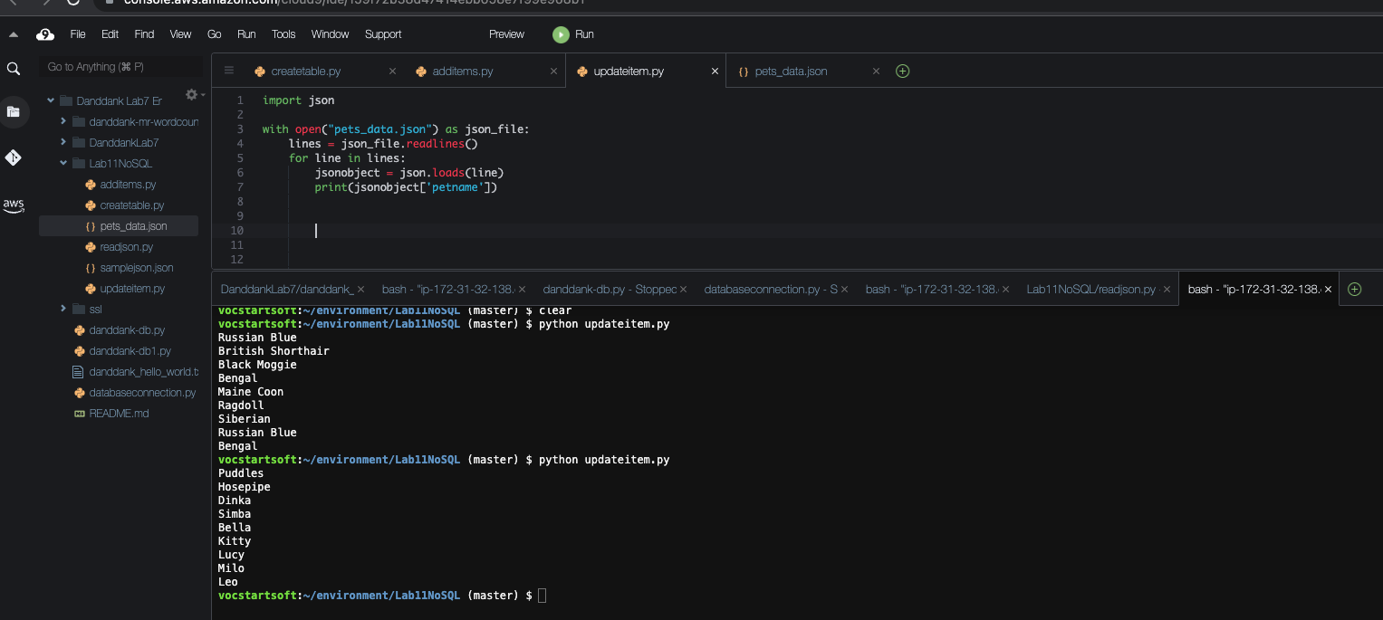

**Lab report screen-shot #13:**

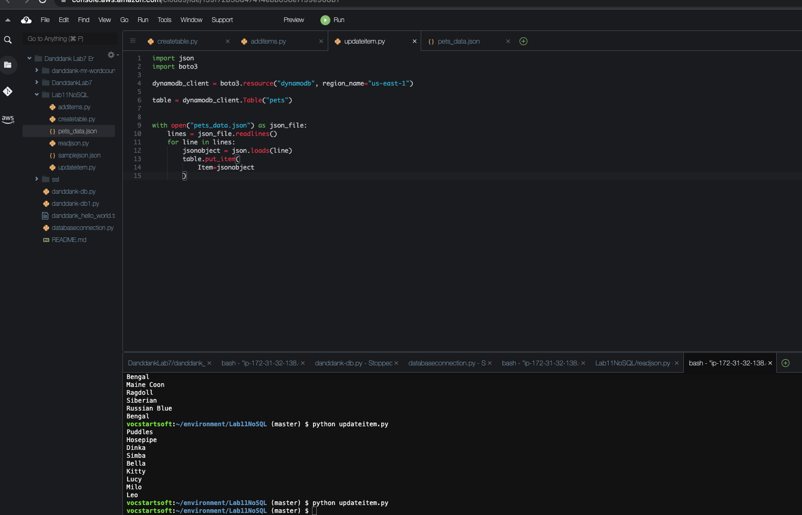

**Lab report screen-shot #14:**

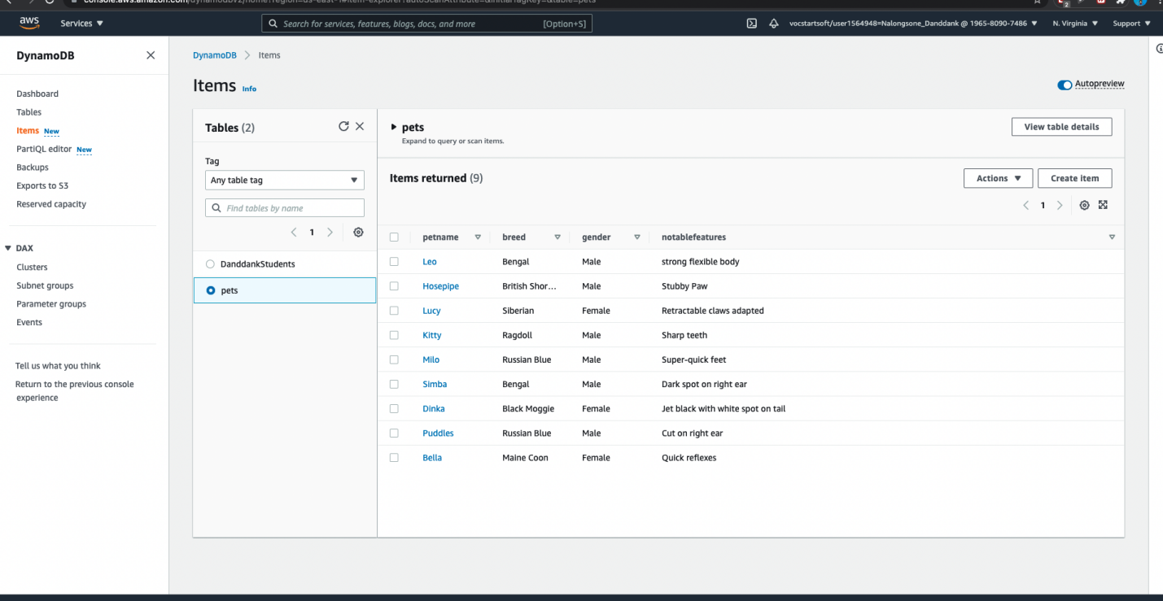

**Lab report screen-shot #15:**

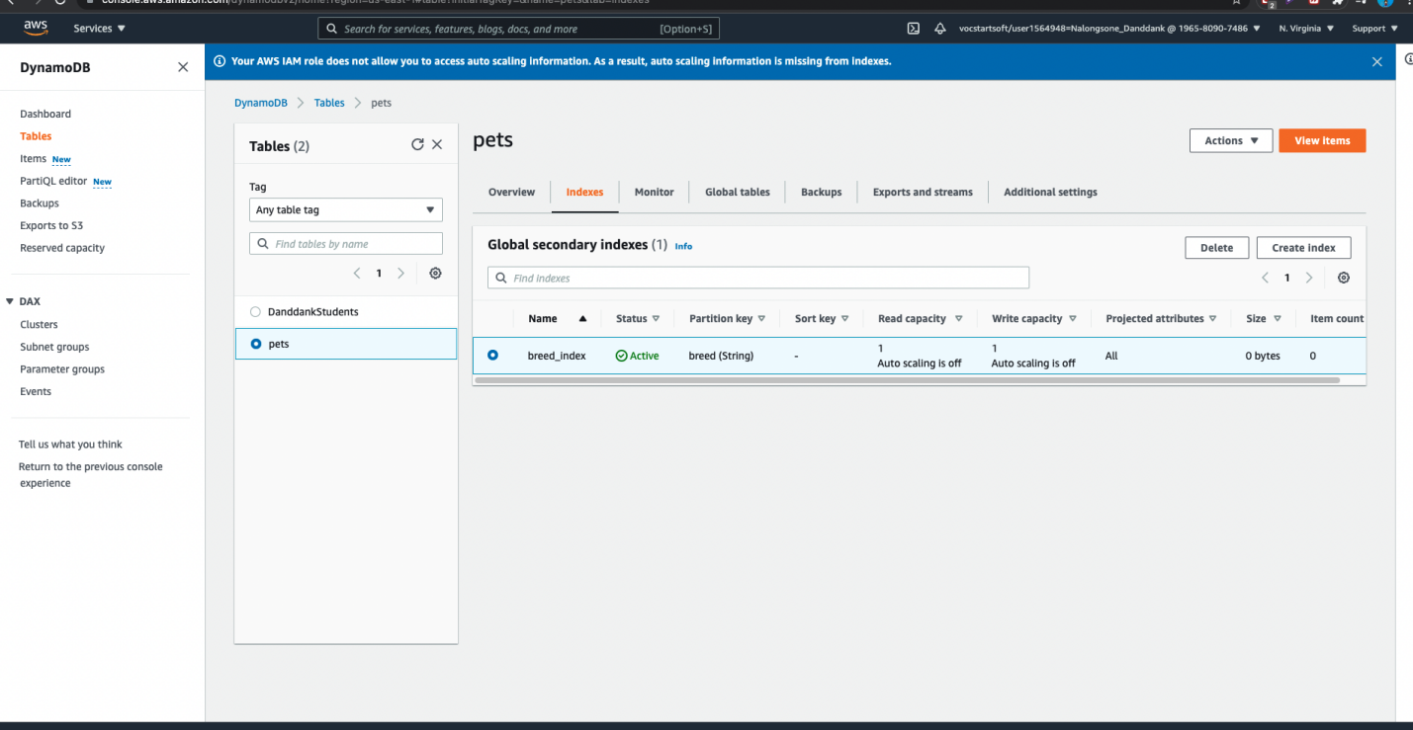

**Lab report screen-shot #16:**

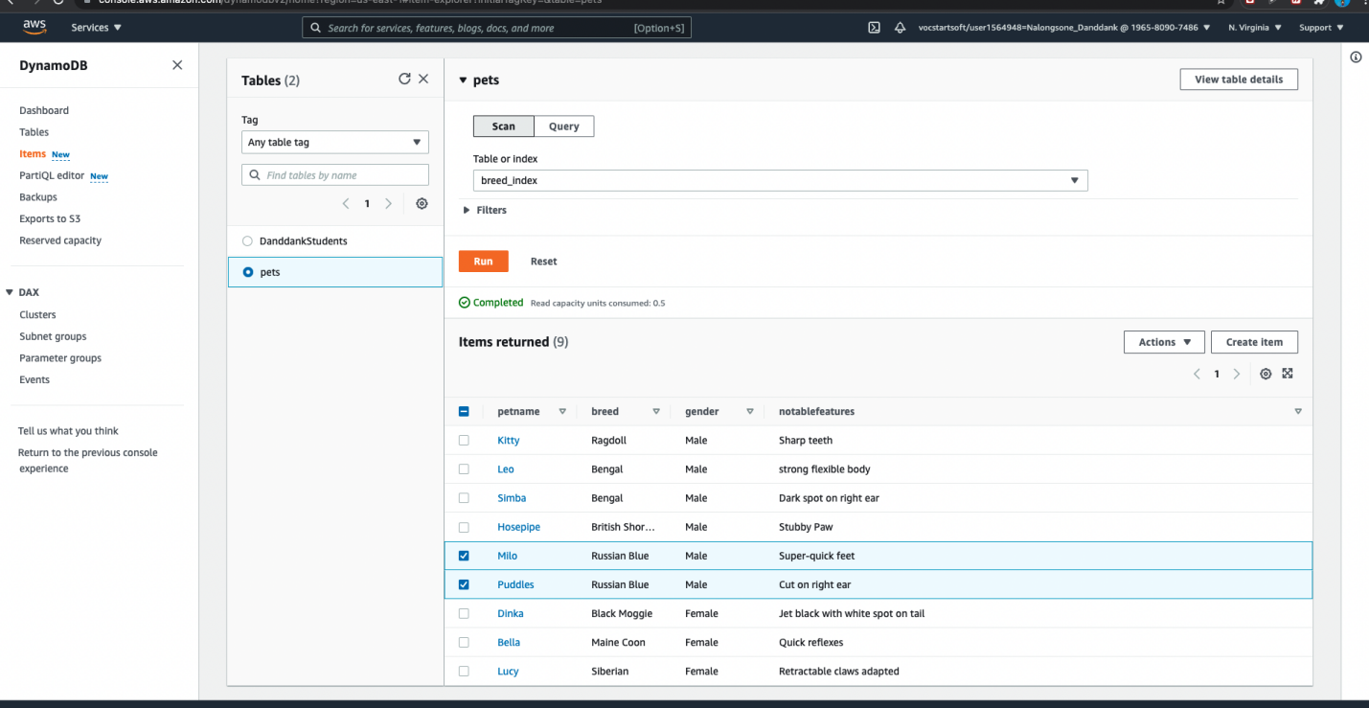

**Lab report screen-shot #17:**

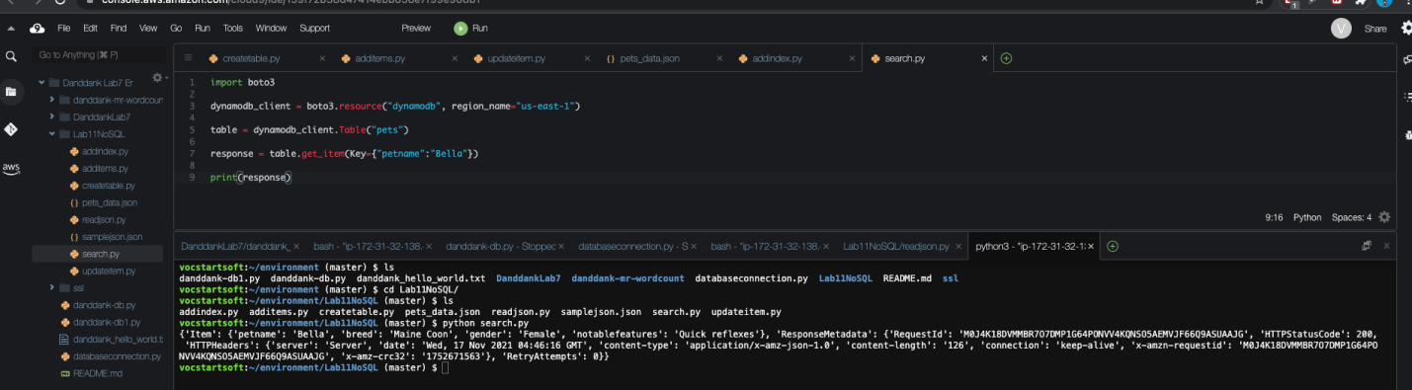

**Lab report screen-shot #18:**

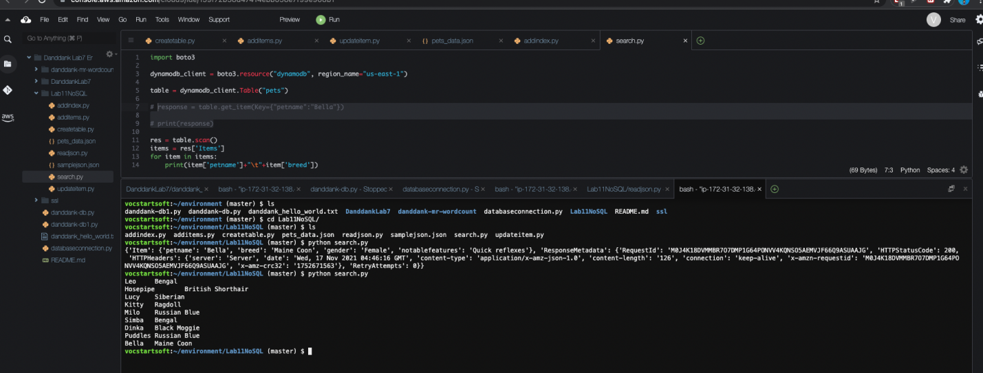

**Lab report screen-shot #19:**

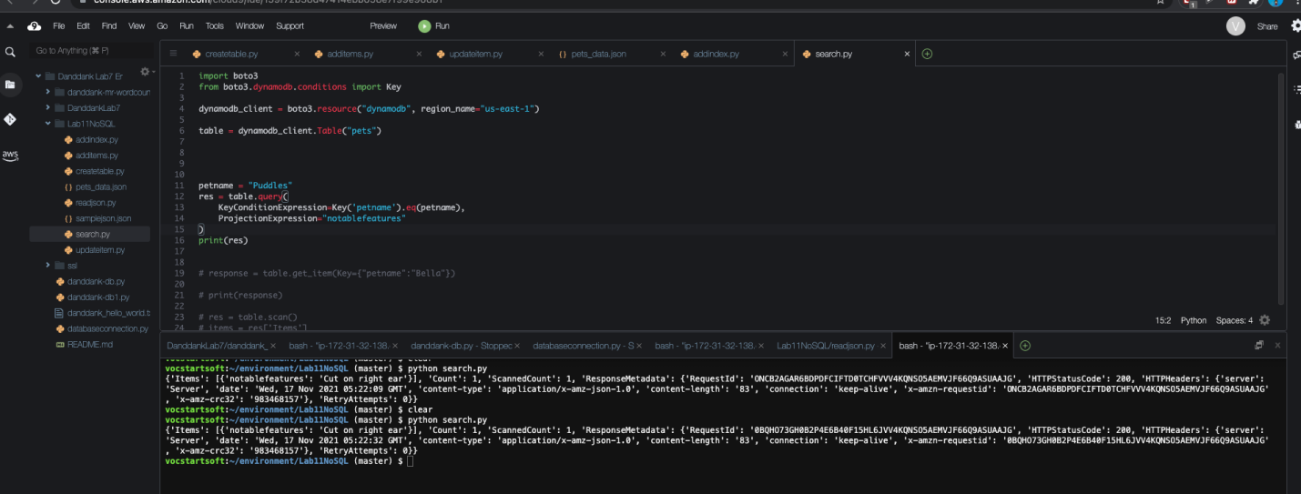

**Lab report screen-shot #20:**

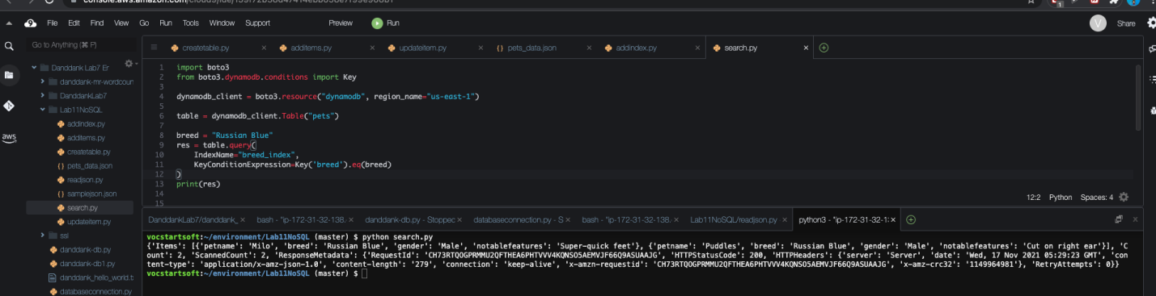

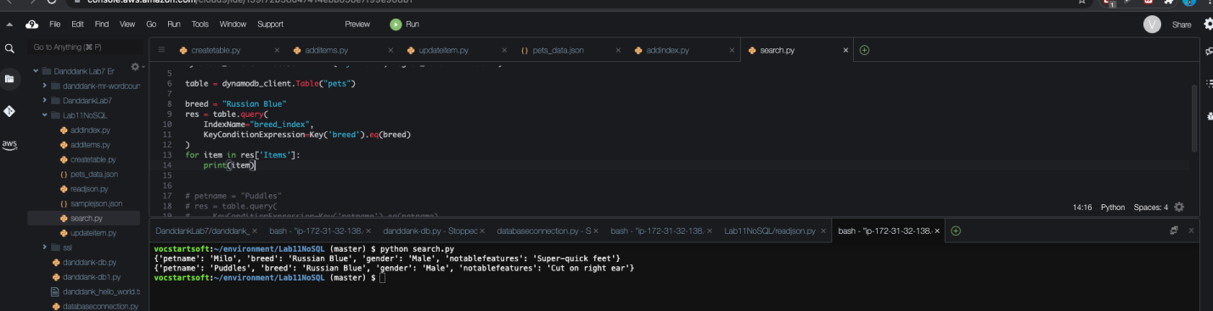

**Lab report screen-shot #21:**

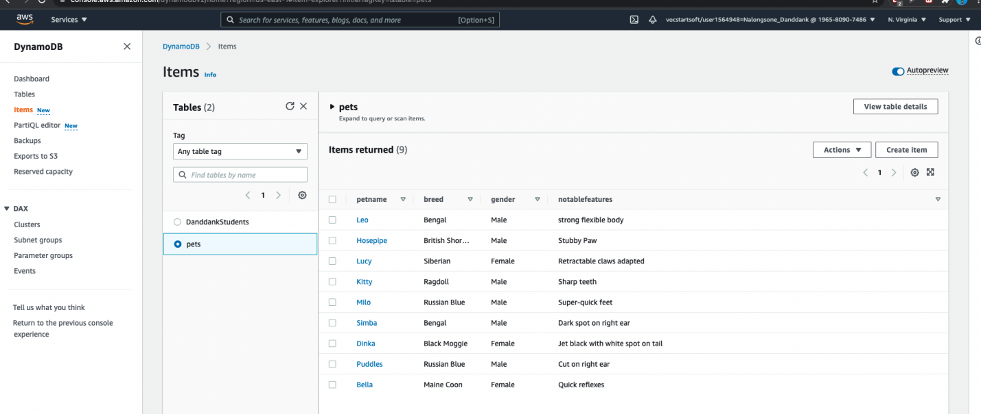

**Exercise 3: Google Firestore Document Database**

**Lab report screen-shot #22:**

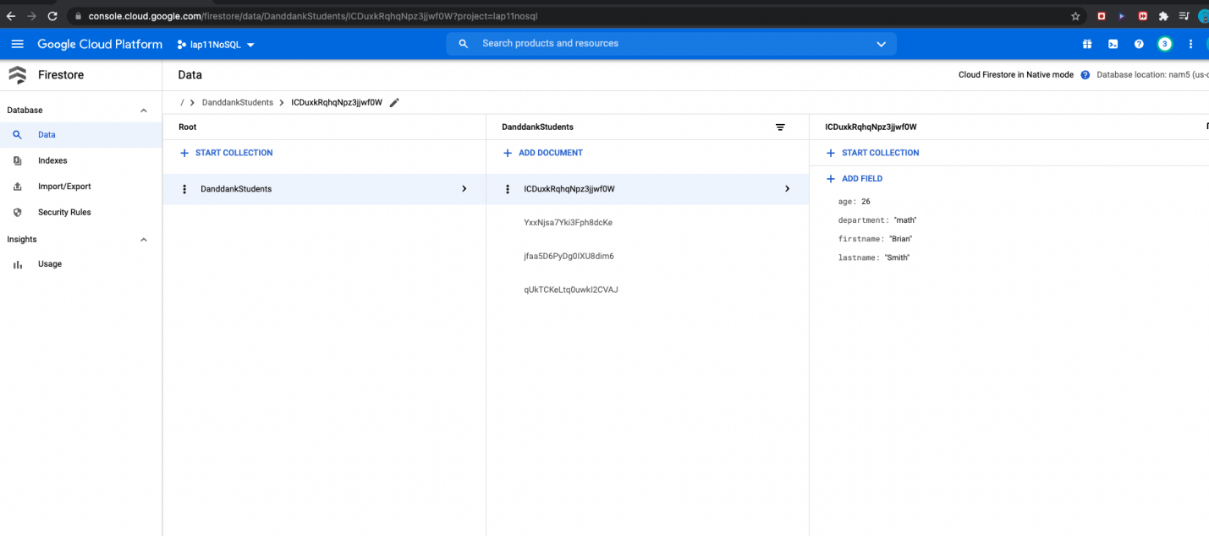

**Lab report screen-shot #23:**

.collection("DanddankStudents")

.where("department", "==", "csc")

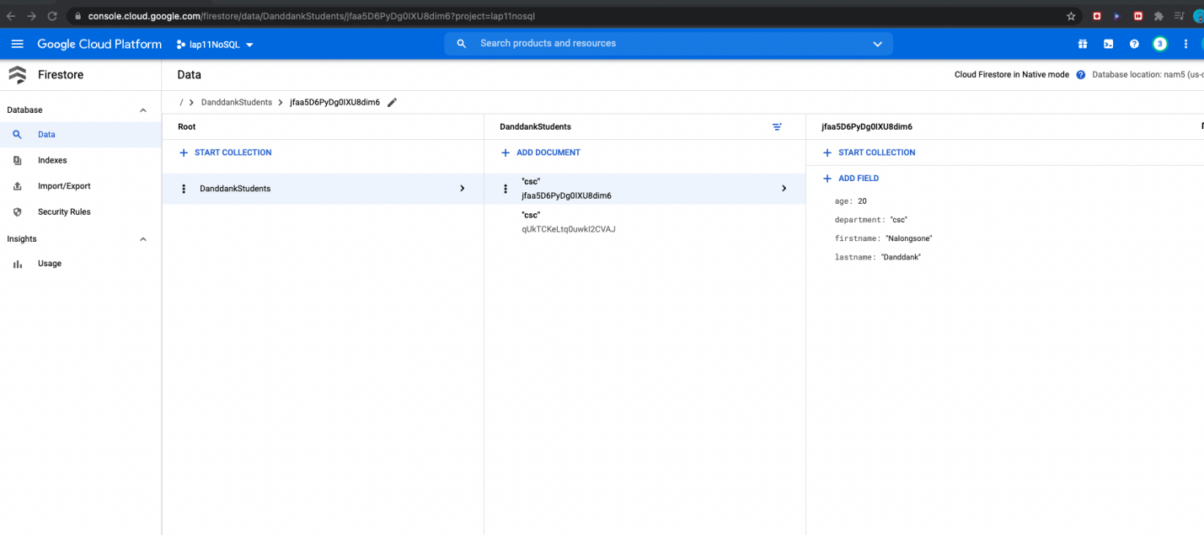

**Lab report screen-shot #24:**

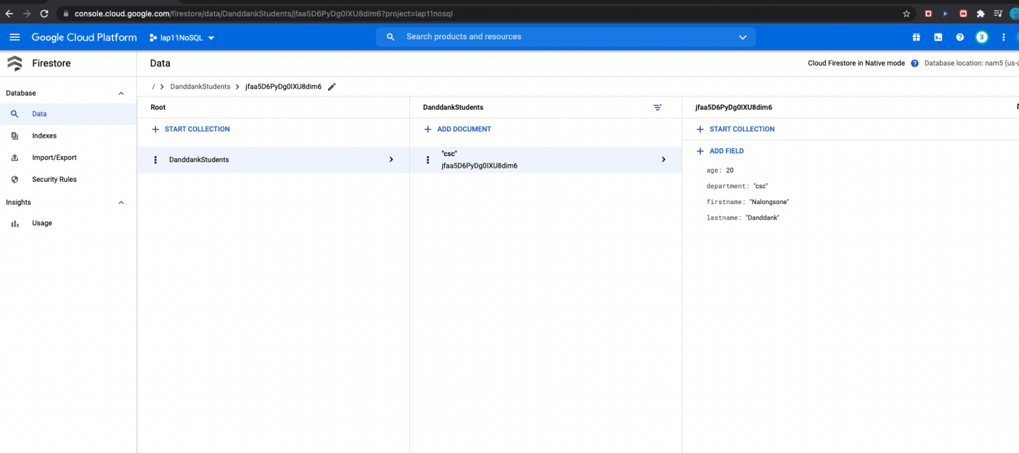

**Lab report screen-shot #25:**

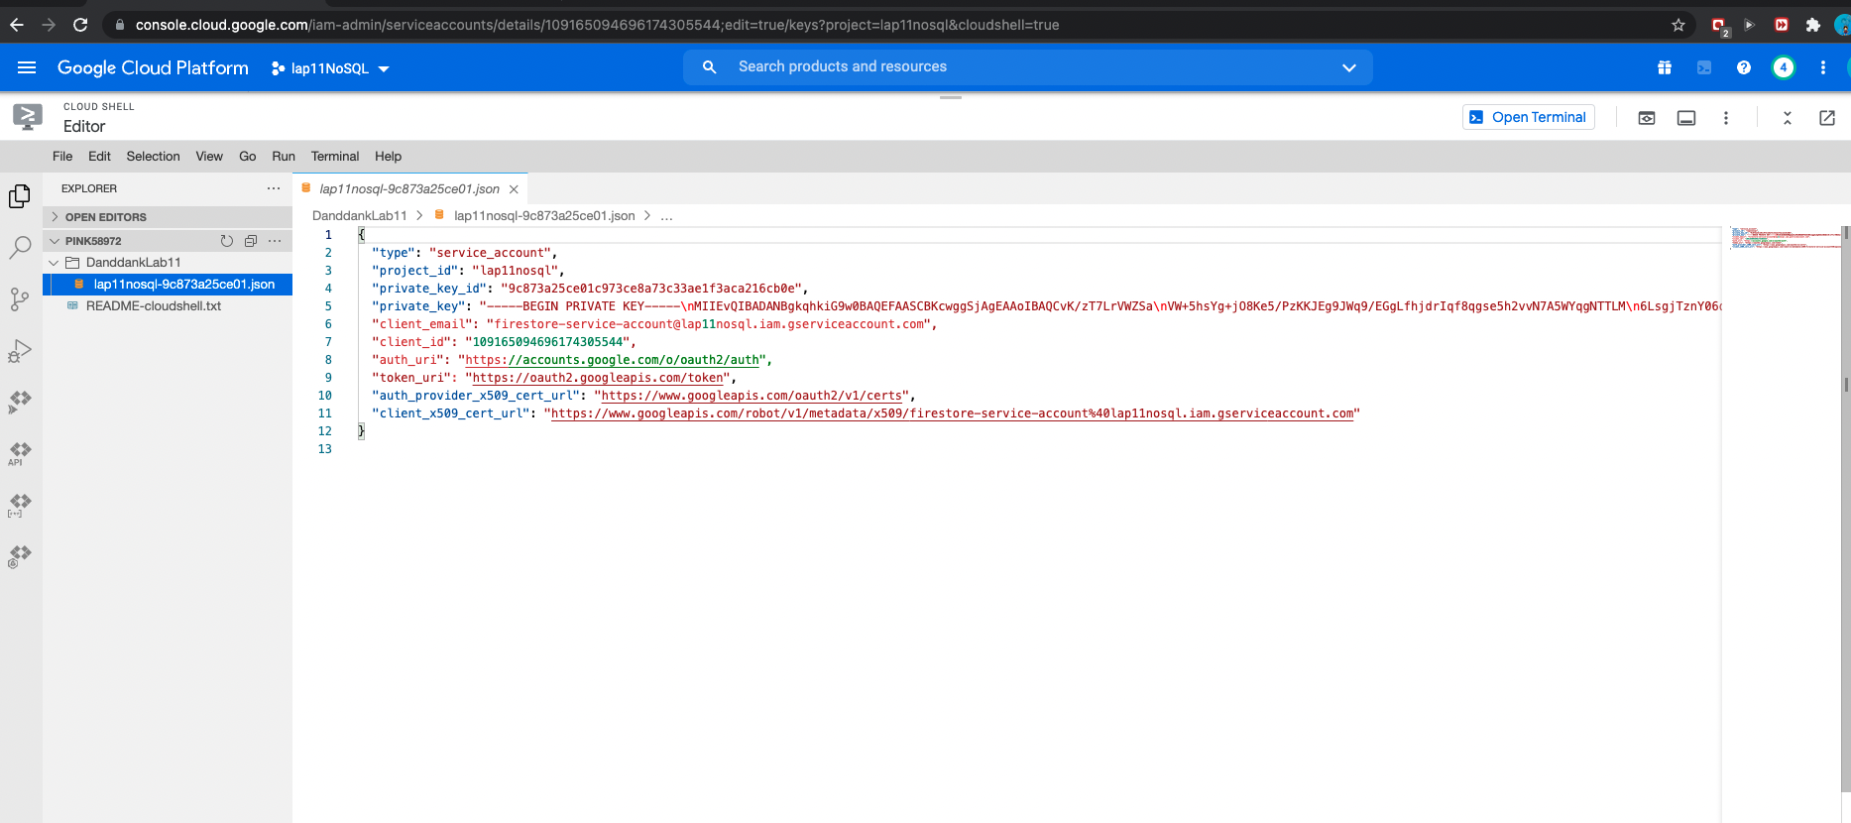

**Lab report screen-shot #26:**

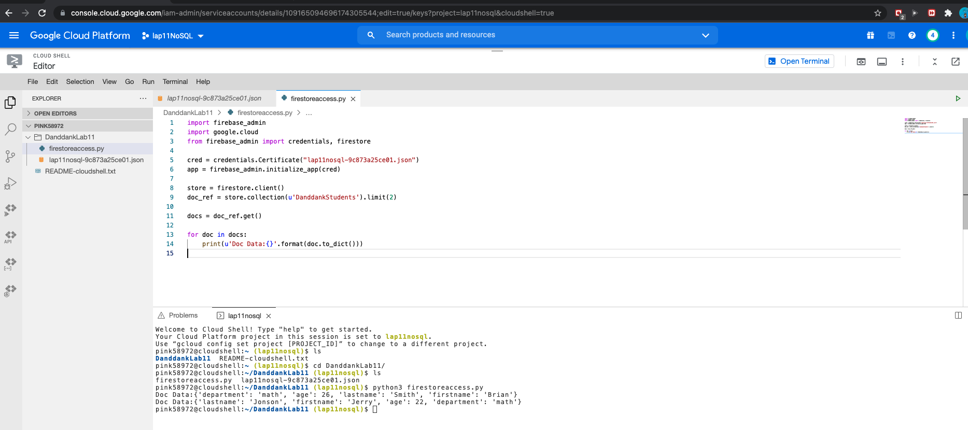

**Lab report screen-shot #27:**

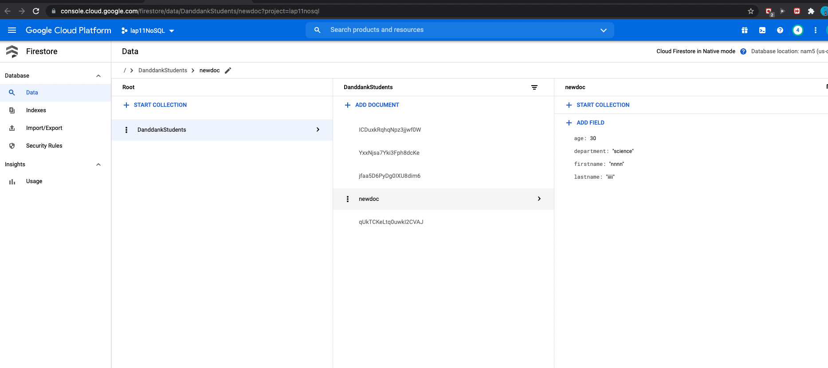

**Lab report screen-shot #28:**

